Solution Architecture Specification
Activate AI Platform – AI Apps Platform and AI Gateway
Recommended Architecture
Product Name: Activate AI Platform – AI Apps Platform and AI Gateway
Architecture Option: Recommended target architecture, roadmap and delivery plan
Prepared for: Activate Interactive – product leadership
Prepared by: Activate Interactive Pte Ltd
Release: 1.8 (Draft for review) – additions (†) from the RESPONSIBLE-AI-ENTERPRISEREADY roadmap review (2 October 2026): gateway admin console (Proxy Manager) with DB-managed runtime configuration, scoped gateway settings (org → department → app → key), AI App–AI Gateway integration contract (discovery document, capability manifest, build-time credentials, token exchange, events), guided configuration and configuration copilot, LiteLLM capability discovery, admin audit view (R9; Appendices A–B updated by addition only, other figures still follow Overall Roadmap v1.2); 1.7: request segments and runtime-to-gateway trust, LiteLLM private-only, external providers (Groq) under residency rules, as-built cache hardening (additions †; Phases 0–4 follow the Activate team’s revision in Overall Roadmap v1.2); 1.6: as-built RAG and QuickSight dashboards as generic tools; 1.5: identity effort reflects the existing Entra ID integration; 1.4: bespoke AI app onboarding, no GPU hosting; 1.3: phased roadmap and resource plan (Appendices A–B); 1.2: standalone editions (1.10); – decisions: Entra ID, gateway-managed inference availability, bespoke-model boundary, pricing tiers
Date: 2 October 2026
Author(s): Joseph Stephen, Solutions Architect
Baseline: Product vision brief (1 Oct 2026); AI Gateway as-built specification v1.0; market analysis v1.3

Document References
Ref | Document | Use in this specification
R1 | Product vision brief – AI Apps Platform and AI Gateway (1 Oct 2026) | Requirements baseline
R2 | AI Gateway Solution Architecture Specification v1.0 (as-built review of ai-gateway @ 81f3c5a) | Current state, findings, reusable components
R3 | Architecture and Market Analysis v1.3 (Jeen AI, MixRoute, market sizing) | Competitive position and demand
R4 | RESPONSIBLE-AI-ENTERPRISEREADY project (FastAPI policy-enforcement proxy) | Responsible AI pillars, tools and policy lifecycle
R5 | activepieces-main v0.92.0 (MIT core; Enterprise directory under commercial licence) | Workflow builder and connector framework
R6 | NEA_Local_POC (AI avatar training platform) | Reference bespoke AI app to onboard
R7 | Digital Patient Solution Product Architecture Specification v6 | Document template
R8 | Vendor pricing pages and reviews (Portkey, LiteLLM, Kong, TrueFoundry, Dify, n8n, Activepieces, Copilot Studio), Oct 2026 | Pricing benchmarks (Appendix F)
R9 | RESPONSIBLE-AI-ENTERPRISEREADY: ROADMAP.md, LITELLM_PROXY_MANAGER.md, MULTI_TENANCY_DESIGN.md, RESPONSE_CACHING.md, PROXY_MANAGER_ENTERPRISE_DESIGN.md (2 Oct 2026) | Reference implementation of the LiteLLM Proxy Manager and DB-managed runtime configuration; designs for the settings hierarchy, control-plane integration and guided configuration

Table of Contents

Right-click the table of contents and choose Update Field if page numbers are not shown.

Solution Architecture Specification – Part I

1 Context

1.1 Overview
Business and technical domain, problem, need, and a general description of the solution.
Activate will evolve the AI Gateway POC into a commercial product made of two components that share one platform core:
- AI Apps Platform – lets customers build, publish and run AI applications: templated chat apps, templated agentic apps, a chat-app builder, an agent builder (LangGraph), multi-agent apps with an orchestrator and chat interface, and a workflow builder that runs with or without a chat interface. Apps are published as web apps (installable as PWAs on mobile). The platform also onboards bespoke AI apps (“bring your own app”, e.g. the NEA Local POC) so they can use platform core and AI Gateway services; the apps and their bespoke models stay in their own environment, and the platform does not host GPU-driven models.
- AI Gateway – the single, governed path between those apps (or any external app or agent) and third-party services: third-party LLM providers, RAG, MCP tools and Agent-to-Agent (A2A) communication. It also manages LLM inference availability (multi-provider routing, failover and quotas). It is an OpenAI-compatible proxy with LiteLLM-class routing, the Responsible AI pillars, end-to-end observability, audit, compliance packs (SOC 2, NIST AI RMF, Singapore IM8 and ASEAN country requirements) and FinOps billed by organisation, department, app and user.
Both components are multi-tenant, use Microsoft Entra ID (Azure AD) as the identity platform with OIDC federation to other providers, and are delivered from one codebase as SaaS on AWS, as a dedicated deployment in a customer’s AWS account (including Singapore Government on Commercial Cloud), on-premises, or air-gapped.
Key objectives:
- One governed control point for every AI interaction in a customer organisation, with evidence that satisfies auditors and regulators.
- Let business teams compose chat, agentic and workflow apps from templates without code, and let developers extend them in code.
- Charge back AI cost accurately to organisation, department, app and user.
- Meet Singapore public-sector and regulated-industry requirements first, then Malaysia, Thailand and Indonesia, with in-country hosting.
- Reuse proven open-source components so a small team, augmented by AI coding agents, can deliver GA 1.0 in eight months.

1.2 Solution Options and Rationale
Key architecture decisions: what to build, what to reuse, and why.
Decision | Recommendation | Alternatives considered | Rationale
Product structure | One codebase, three layers: platform core (always installed), AI Gateway runtime (always installed; features enabled by licence) and AI Apps Platform (optional module). Sold as three editions – Gateway, Apps, Suite – through licence entitlements, not separate builds (section 1.10) | Two separate products; one monolith | Either product can be bought alone without duplicating governance code. Apps reach models and tools only through the public gateway interfaces (OpenAI-compatible, MCP, A2A), so Apps-only customers get a governed model path by default and can still point to their own gateway if mandated
Runtime | Kubernetes everywhere: Amazon EKS for SaaS, any CNCF Kubernetes on-prem, packaged as Helm charts | Keep ECS Fargate (as-built) | On-prem and air-gapped delivery need one portable packaging; ECS cannot run on-prem
LLM proxy | Embed LiteLLM open-source proxy as the model-routing data plane behind the Activate control plane | Extend the as-built Bedrock-only router; buy a gateway | LiteLLM gives 100+ providers, OpenAI compatibility, fallbacks and caching; the proxy owns LLM inference availability (multi-provider and multi-region failover, quotas). Activate keeps tenancy, policy, audit and billing
Responsible AI | Promote the RESPONSIBLE-AI-ENTERPRISEREADY policy engine (Presidio, Guardrails AI, policy lifecycle, TruLens, Ragas, Langfuse) into a gateway service; keep Bedrock Guardrails as an optional provider | Only the as-built regex guardrails | Covers all eight pillars with open-source tools that also run air-gapped
Workflow builder | Embed Activepieces Community Edition (MIT) engine and builder; build tenancy, SSO, audit and RBAC in the Activate core | Activepieces Enterprise licence; build from scratch; n8n (sustainable-use licence) | Activepieces EE (platform admin, SSO/SCIM, audit, API keys, secret managers, embedding, branding) needs a per-seat commercial licence for production. Using CE plus Activate’s own core avoids that cost and lock-in
Agent framework | LangGraph for single and multi-agent apps; A2A protocol for agent-to-agent; MCP for tools | Proprietary agent DSL; CrewAI | LangGraph is the most widely adopted stateful agent runtime; A2A and MCP are the open interoperability standards
Identity | Microsoft Entra ID (Azure AD) as the platform identity provider; Entra External ID for customer tenants, federating to any OIDC / SAML provider (Okta, Google, Singpass / Corppass); SCIM provisioning. Keycloak only where Entra is unreachable (on-prem without internet, air-gapped) | Cognito; Keycloak everywhere | Decided: aligns with the as-built Entra BFF login and most enterprise and government customers; Keycloak covers disconnected sites
Data | PostgreSQL + pgvector (Aurora in AWS, CloudNativePG on-prem), Valkey, S3/MinIO, SQS/NATS behind adapters | Separate vector DB | Fewest moving parts that work in every deployment mode
Model boundary | Only third-party model providers are reached through the AI Gateway; bespoke models (fine-tuned or custom, e.g. NEA ASR / TTS / avatar models) run in the owning app’s own environment, outside the platform | Route every model through the gateway | Decided: bespoke models are app-specific, latency-sensitive and often GPU-local; the gateway governs external providers where data leaves the app boundary
Tenancy model | Pooled tenants with enforced RLS by default; silo (dedicated account / database) for premium and regulated tenants; dedicated deployments for government | Silo for all | Balances cost with isolation; aligns with the AWS SaaS Lens

1.3 Context Diagram(s)
High-level diagram of the solution depicting user interfaces and integration interfaces.
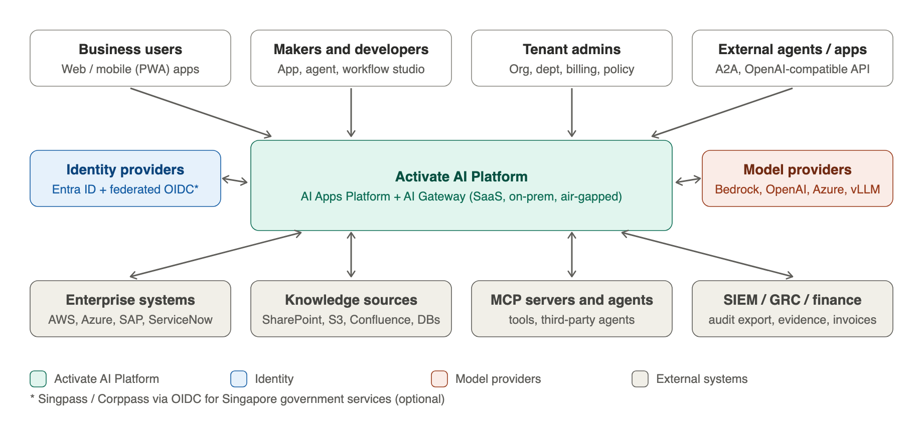
Figure 1 – Activate AI Platform context

1.4 User Interfaces
Interfaces available to users – consistent with the context diagram.
Interface | Users | Description
Published apps | Business users, citizens, customers | Chat, agentic and workflow apps published as responsive web apps, installable as PWAs on iOS and Android; optional embed widget/SDK
Studio | Makers, developers | App Studio (templates, chat app builder), Agent Builder (LangGraph graph editor + code), multi-agent orchestrator designer, Workflow Builder, prompt and evaluation workbench
Admin console | Tenant admins, department heads, finance | Organisations, departments, apps, users; identity providers; policies and approvals; budgets and chargeback; compliance evidence
Operator console | Activate operations (SaaS) | Tenant lifecycle, quotas, release rings, health, incident and support tooling
APIs | Developers, external apps and agents | OpenAI-compatible LLM API, A2A endpoints, MCP endpoints, platform REST API

1.5 Functionality
Functionality provided by the solution.
Product | Capability | Scope | Reuse from
AI Apps Platform | Templated chat apps | HR, policy, knowledge, citizen-service templates; per-app persona, RAG sources, guardrail profile | AI Gateway UI and applications model
 | Templated agentic apps | Pre-built LangGraph agents (case triage, report authoring, procurement, IT helpdesk) | New
 | Build your own chat app | No-code builder: prompt, knowledge, tools, UI theme, publish | AI Gateway applications
 | Build agentic apps | LangGraph graph editor + code mode, tools via MCP, memory, human-in-the-loop | Agent loop design (as-built P0–P3)
 | Multi-agent apps | Supervisor/orchestrator with sub-agents (local or remote via A2A) and chat interface | New
 | Workflow builder | Event, schedule, webhook, form or chat triggers; 280+ connector pieces; approvals; publish with or without chat | Activepieces CE
 | Integration Hub | Secure application-to-application calls to AWS, Azure, SAP, ServiceNow and REST APIs through vaulted credentials and an egress proxy | Activepieces pieces + new
 | Publishing | Versioned releases, custom domains, PWA packaging, approval before publish | New
 | Bespoke AI app onboarding | Onboard existing bespoke apps (e.g. NEA Local POC) to platform core services (sign-in, tenancy, audit, observability, metering) and AI Gateway services; the apps and their bespoke models stay in their own environment – no GPU or model hosting | New
AI Gateway | LLM proxy | OpenAI-compatible interface to third-party model providers; inference availability management (multi-provider / multi-region routing, fallback, quotas); load balancing, semantic cache, virtual keys | LiteLLM OSS + as-built router
 | Responsible AI | Eight pillars (section 3.1) with policy lifecycle draft → review → approved → active → deprecated | RESPONSIBLE-AI project + as-built guardrails
 | RAG (generic knowledge tool) | As-built: sources, upload / ingest API, hybrid search, re-ranking, tenant and permission filtering; exposed as an MCP tool for any app; source connectors via Activepieces pieces feeding the ingest API | As-built RAG
 | Analytics (generic tool) | As-built AWS QuickSight natural-language dashboard authoring, embedding and publishing, generalised from GRL@PA to pluggable data sources | As-built QuickSight + GRL@PA MCP
 | MCP gateway | Registry, OAuth 2.1 for MCP, tool ACLs per tenant/app, tool-call audit | As-built MCP client/registry
 | A2A gateway | Agent cards, discovery, authentication, routing and policy for agent-to-agent calls | New
 | Observability and audit | OpenTelemetry traces end to end, Langfuse LLM traces, hash-chained WORM audit, SIEM export | As-built + RESPONSIBLE-AI
 | Compliance packs | Control mappings and evidence for SOC 2, NIST AI RMF, ISO/IEC 42001, IM8, MY/TH/ID/VN/PH | New
 | FinOps | Metering and chargeback by organisation, department, app, user; budgets, quotas, alerts, invoice export | As-built billing
 | Gateway admin console (Proxy Manager) | Providers, models and prices, credentials (Secrets Manager or LiteLLM encrypted store), keys and teams with budgets and rotation, MCP servers, proxy guardrails, routing / fallback / cache / general settings held in the proxy database; allow-listed, audited passthrough; scoped per org → department → app → key | RESPONSIBLE-AI project (Proxy Manager, verified 2 Oct 2026)
 | Guided configuration | Settings catalogue with recommended values per environment, pre-save validation, configuration profiles; propose-only configuration copilot grounded in docs, effective configuration and FinOps / AIOps signals | New (design in R9)

1.6 Data
Type of data managed by the solution.
Data | Examples | Handling
Tenant and identity | Organisations, departments, apps, users, groups, IdP configuration | Tenant-scoped, RLS enforced
App definitions | Chat apps, agent graphs, workflows, templates, versions | Tenant-scoped; versioned; exportable
Conversations and runs | Chat history, agent state, workflow runs, A2A messages | Tenant-scoped; retention policy per tenant; PII redacted before model calls
Knowledge | Documents, chunks, embeddings, source permissions | Tenant-scoped indexes; permission trimming at query time
Governance | Policies, decisions, evaluations, approvals, audit | Hash-chained; copied to WORM storage; hashed prompts only in audit
Metering | Usage events, prices, budgets, invoices | Aggregated by org → dept → app → user
Secrets | Provider keys, connector credentials, OAuth tokens | KMS / Vault; never in the database in clear

1.7 Integration Interfaces
Interfaces available to other systems – consistent with the context diagram.
Interface | Direction | Protocol / auth | Purpose
LLM API | Inbound | OpenAI-compatible REST + SSE; virtual keys or OIDC tokens | Any app or agent calls models through the gateway
A2A | Inbound / outbound | A2A protocol (JSON-RPC over HTTPS), agent cards, OAuth 2.0 / mTLS | Agent-to-agent tasks across tenants and vendors
MCP | Inbound / outbound | MCP Streamable HTTP, OAuth 2.1 | Tool access for agents and external MCP clients
Identity | Outbound | Microsoft Entra ID / Entra External ID (OIDC, SAML federation to other providers), SCIM 2.0 | Sign-in and user provisioning
Model providers | Outbound | Bedrock (SigV4), OpenAI/Azure/Google/Anthropic APIs, vLLM | Inference
Enterprise systems | Outbound | REST/OData/SOAP; AWS SigV4; Azure AD app credentials; SAP OData/BAPI via connector | Application-to-application integration
Webhooks and events | Inbound / outbound | HMAC-signed webhooks; EventBridge | Triggers and notifications
Exports | Outbound | SIEM (syslog/OTLP), S3 evidence bundles, invoice CSV/API | Security, compliance and finance
Discovery and management | Inbound | /.well-known/ai-gateway (unauthenticated); capability manifest and management API with OIDC, gateway token exchange and OAuth 2.0 client credentials carrying gateway scopes | The AI App control plane and partner platforms discover gateway capabilities at run time and manage their tenant’s gateway configuration

1.8 Usage Profile and Sizing Assumptions
Planning envelope for GA 1.0 and GA 2.0.
Parameter | GA 1.0 (Jun 2027) | GA 2.0 (Oct 2027)
Tenants (organisations) | 5–10 | 30–50
Named users per tenant | 100 | 1,000
Concurrent agents per tenant | 50 | 1,000
Peak gateway requests | ≈ 5 req/s | ≈ 150 req/s sustained (agents)
Peak model throughput | ≈ 1M tokens/min | ≈ 20M tokens/min (needs provisioned or raised quotas)
Gateway overhead target (p95, excluding model time) | < 150 ms | < 100 ms
Availability target (SaaS) | 99.5% | 99.9%

1.9 Commercial Model and Pricing Tiers
Recommended three tiers (Suite prices), benchmarked against published AI gateway and AI app-builder pricing (Appendix F). Edition pricing is in section 1.10.
Competitors price in three shapes: free or low-cost developer tiers (Portkey, TrueFoundry, Dify, Activepieces), mid-market team plans of roughly US$50–3,000 a month (Dify Team, n8n Business, TrueFoundry Pro Plus, Portkey Production), and custom enterprise contracts that start around US$30,000 a year (LiteLLM Enterprise, Kong Konnect Enterprise, MixRoute Enterprise top-up) and reach about US$360,000 a year for a full suite (Jeen Platform list price). Activate sells gateway and app platform together, with governance and sovereignty as the differentiator, so the tiers sit above single-purpose tools and well below full suites.
 | Team | Business | Enterprise / Sovereign
Target | Department or SME starting with governed AI | Organisation-wide AI with chargeback and compliance | Government, regulated and large enterprises
Deployment | SaaS pooled (Singapore) | SaaS pooled or silo; choice of ASEAN region | Silo SaaS, customer AWS / GCC, on-prem or air-gapped
Platform fee (indicative) | US$1,200 / month (annual) | US$4,500 / month (annual) | From US$120,000 / year (custom)
Included users | 100 | 1,000 | Unlimited (per agreement)
Apps and workflows | 10 published apps; 20 active workflows | 50 apps; 100 active workflows; agents and multi-agent | Unlimited; bespoke AI app onboarding
AI Gateway | 1M gateway requests / month; LLM proxy; RAG; MCP | 10M requests / month; A2A; evaluation; semantic cache | Custom volume; provisioned capacity
Identity and governance | Entra ID SSO; standard Responsible AI policies; 30-day logs | + SCIM, ABAC, custom policies and approval workflow; 1-year audit retention | + customer-managed keys, residency, WORM audit export, custom retention
Compliance packs | Singapore baseline | IM8 + NIST AI RMF + one ASEAN country | All packs; SOC 2 report; AI Verify export
FinOps | Org and app cost reports | Org → department → app → user chargeback, budgets, invoices | + ERP / finance integration
Support and SLA | Business hours; 99.5% | 24×5; 99.9% | 24×7; 99.95% (silo SaaS); named TAM
Model tokens | Bring your own provider keys (no markup) or Activate-billed at cost + 8% | Same | Same, or customer contracts only
Overage | US$150 per extra 1M requests; US$8 per extra user | US$100 per extra 1M requests; US$5 per extra user | Contracted
- Prices are indicative list prices in USD before GST, for validation with design partners (Open Item 1). Government tenders will typically be priced per deployment plus implementation services.
- The token margin funds gateway operations; customers can always bring their own provider keys, as MixRoute and LiteLLM users expect.
- Implementation, bespoke apps and BYOA onboarding are sold as professional services in addition to the platform fee.

1.10 Product Packaging and Standalone Purchase
What a customer gets when it buys only the AI Gateway, only the AI Apps Platform, or both.
The two products share one platform core, and the Apps Platform depends on a model path. Packaging therefore uses licence entitlements on one deployment: the core and the gateway runtime are always installed; the licence decides which features are switched on. The Apps Platform talks to the gateway only through its public interfaces, so it can also run against a customer’s existing gateway.
Capability | Gateway edition | Apps edition | Suite (both)
Platform core: tenancy, Entra ID sign-in, RBAC/ABAC, audit, observability, metering | Included | Included | Included
LLM proxy for platform apps (model access, provider keys, routing, failover) | Included | Included as Gateway Essentials | Included
Baseline guardrails (PII redaction, content safety) on app traffic | Included | Included as Gateway Essentials | Included
Gateway for external apps and agents (OpenAI-compatible API, virtual keys for non-platform apps) | Included | Not included | Included
Full Responsible AI engine (custom policies, lifecycle, approvals, evaluation, red-teaming) | Included | Upgrade | Included
MCP and A2A gateways for external tools and agents | Included | Platform apps only | Included
Compliance packs (IM8, NIST AI RMF, SOC 2 evidence, ASEAN) | Gateway scope | App scope | End to end
FinOps chargeback org → department → app → user | Included (by key / app / user) | Included for platform apps | Included
App Studio, chat and agent templates, agent builder, multi-agent, workflow builder, publishing | Not included | Included | Included
Integration Hub (AWS, Azure, SAP) and bespoke AI app onboarding | Not included | Included | Included

Gateway Edition Only
- The customer’s own apps and agents (any framework, e.g. Copilot Studio, custom LangGraph, vendor apps) call the gateway through its OpenAI-compatible, MCP and A2A interfaces. The Apps Platform module is not deployed and its UI is hidden.
- All gateway capabilities apply: policy, audit, observability, availability management and chargeback by key, app and user.
- This is the cleanest standalone case – no functional gap.

Apps Edition Only
- Default: the gateway runtime is still installed as Gateway Essentials – model access with provider keys, routing and failover, baseline guardrails, metering per app. Apps keep working and stay governed; the gateway is not exposed to non-platform apps and advanced features are locked.
- Customer-mandated external gateway (e.g. an existing Azure API Management, Kong or Portkey gateway, or a central government gateway): the Apps Platform’s model adapter points to that OpenAI-compatible endpoint. Policy enforcement, provider availability and model-cost data then belong to the customer’s gateway; Activate keeps app-level audit, traces and usage, and the compliance pack covers app scope only. This trade-off is recorded in the contract.
- Upgrade to Suite is a licence change – no migration, because the gateway runtime is already deployed and metering history is shared.

Architecture Requirements This Creates
Requirement | Design response | Release
Licence entitlements per tenant | Entitlement service in the platform core; signed licence files for on-prem and air-gapped; features checked at API and UI | Phase 0 (platform core, tenant and admin portal)
Apps must not use gateway internals | Apps call only the public OpenAI-compatible, MCP and A2A interfaces; contract tests run against the Activate gateway and one third-party gateway | Phase 1 onwards
External gateway adapter | Configurable model endpoint, auth (API key, OAuth, mTLS) and header mapping for org / app / user attribution | After Phase 4 (backlog)
Modular deployment | Helm umbrella chart with subcharts per module (enabled flags); module-scoped database migrations | After Phase 4 (EKS + Helm packaging)
Separate SKUs in billing | Metering tags every event with the edition and module; invoices per edition | Phase 1 (usage export / billing)

Pricing by Edition
The tier prices in section 1.9 are Suite prices. As a starting point for validation: Gateway edition about 50% of the Suite fee, Apps edition (including Gateway Essentials) about 70%, so buying both as a Suite is cheaper than buying them separately. Example for the Business tier: Gateway ≈ US$2,250, Apps ≈ US$3,150, Suite US$4,500 per month.

Solution Architecture Specification – Part II

2 Specifications

2.1 Components and Deployment Diagram(s)
Logical target architecture.
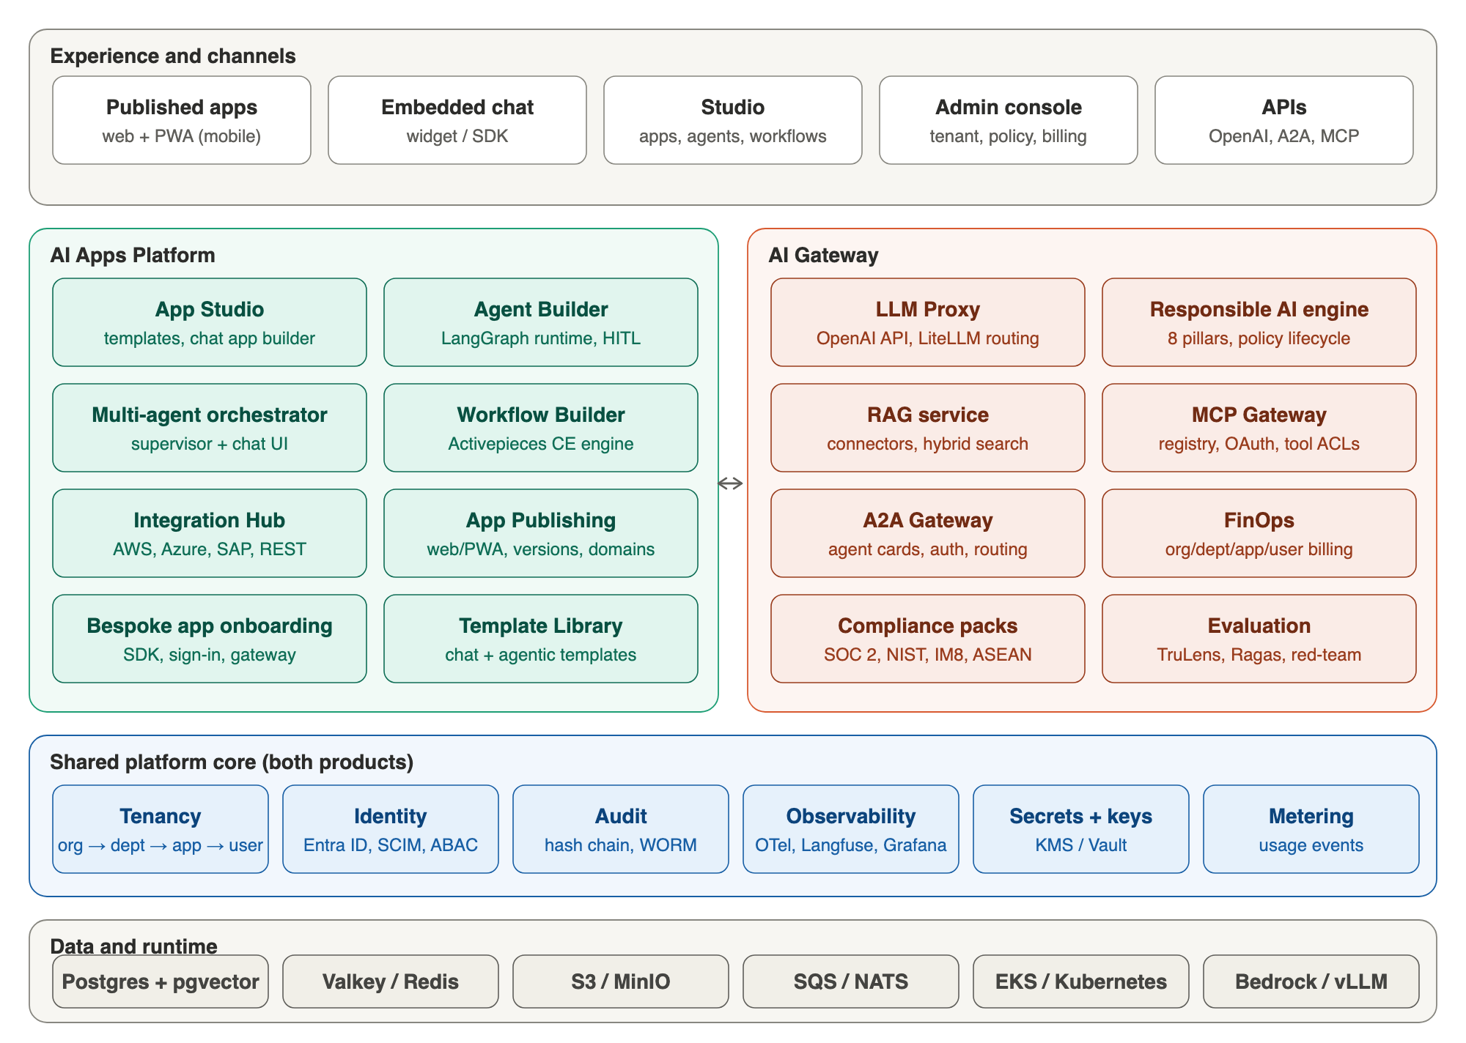
Figure 2 – Logical architecture: two products on one platform core

Key Design Decisions
- Apps never call third-party models, tools or agents directly: every outbound call to a third-party provider goes through the AI Gateway, so policy, audit and billing are applied once and uniformly. Bespoke models are the exception – they run in the app’s own backend (see Model Boundary below).
- The platform core owns tenancy, identity, audit, observability, secrets and metering; both products consume it through internal APIs and shared libraries.
- Control plane and data plane are separated: configuration changes flow through the control plane; the gateway data plane is stateless and horizontally scalable.
- Every external dependency sits behind an adapter so SaaS, on-prem and air-gapped share one codebase.
- Hot-path state (limits, budgets, sessions) lives in Valkey; durable records (usage, audit) are written asynchronously through a queue – fixing the per-tenant lock contention found in the as-built review.

Model Boundary
Model type | Example | Path | Governance
Third-party provider models | Bedrock (Claude, Llama, Nova), OpenAI, Azure OpenAI, Google, Anthropic | App → AI Gateway LLM proxy → provider | Full gateway policy, audit, billing and availability management
Open-weight models served by the platform | vLLM-hosted Llama / Qwen in on-prem or air-gapped sites | Registered as a provider behind the LLM proxy | Same as third-party
Bespoke models | NEA ASR / TTS / avatar models, customer fine-tunes | App calls its own model service directly, outside the platform | App emits OpenTelemetry traces, usage and audit events via the platform SDK; optional Responsible AI checks via the policy-engine API

2.2 AWS System Architecture
SaaS and dedicated deployments on AWS.
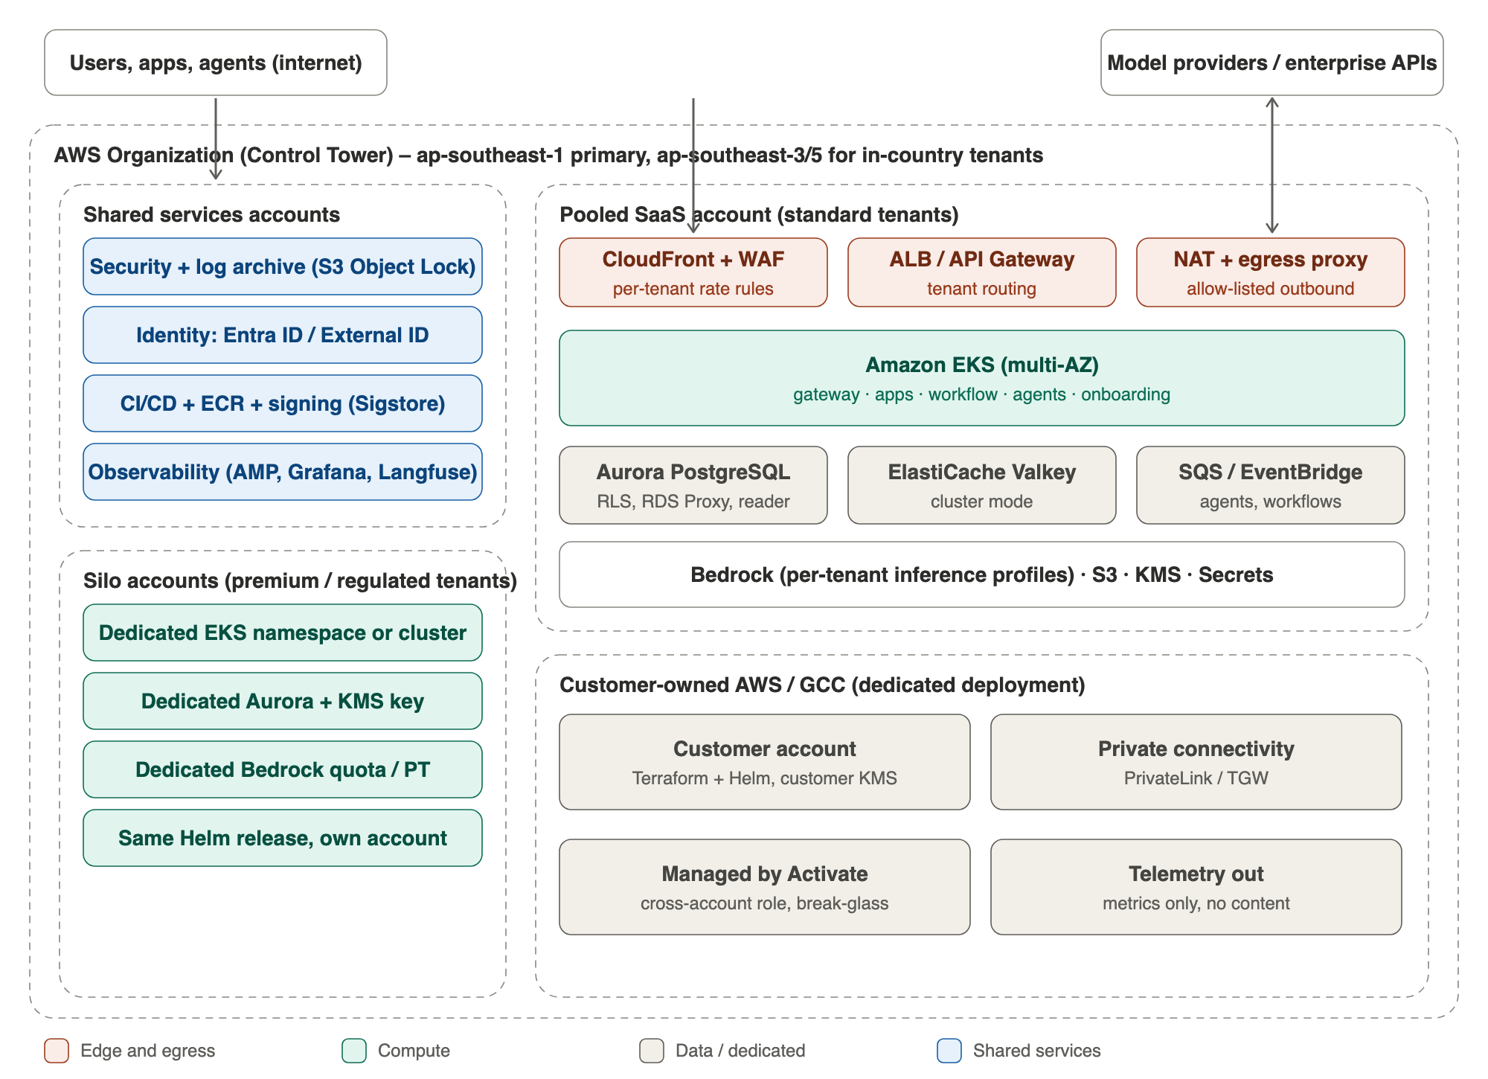
Figure 3 – AWS architecture for SaaS (pooled and silo) and customer-owned deployments
Element | Design
Accounts | AWS Organizations with Control Tower: security / log-archive, shared services, pooled SaaS per region, silo accounts per premium tenant, sandbox and staging
Regions | ap-southeast-1 (Singapore) primary; ap-southeast-3 (Jakarta), ap-southeast-5 (Malaysia) and ap-southeast-7 (Thailand) for in-country tenants; DR pair per region
Edge | CloudFront + WAF (per-tenant and per-key rate rules), ALB / API Gateway; Shield Standard
Compute | EKS multi-AZ with Karpenter; namespaces per product with network policies; no GPU or bespoke-model hosting
Data | Aurora PostgreSQL (writer + reader, RDS Proxy), ElastiCache Valkey cluster, S3 with per-tenant prefixes and KMS keys, SQS/EventBridge
Models | Bedrock in-region with per-tenant application inference profiles for quota and cost attribution; provisioned throughput for heavy agent tenants; external providers via egress proxy
Egress | NAT per AZ through an egress proxy with per-tenant allow-lists; VPC endpoints for Bedrock, S3, Secrets Manager, ECR

2.3 Deployment Modes
One product, four ways to run it.
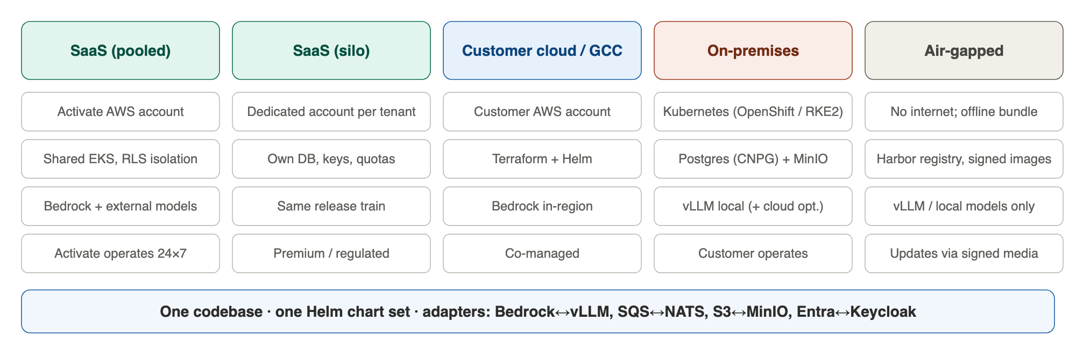
Figure 4 – Deployment modes
Concern | SaaS | Customer cloud / GCC | On-premises | Air-gapped
Kubernetes | EKS | EKS in customer account | OpenShift, RKE2, EKS Anywhere | Same, offline
Identity | Entra ID / Entra External ID | Entra ID (customer or Activate tenant) | Entra ID if reachable, else Keycloak | Keycloak + local directory
Third-party models (via gateway) | Bedrock + external providers | Bedrock in-region + approved providers | Optional cloud providers; open-weight models served by vLLM registered as a provider | Open-weight models served by vLLM registered as a provider
Bespoke models | Stay with the onboarded app (not hosted) | Stay with the onboarded app | Stay with the onboarded app | Stay with the onboarded app
Data | Aurora, Valkey, S3, SQS | Same, customer KMS | CloudNativePG, Valkey, MinIO, NATS | Same
Updates | Continuous (release rings) | Monthly, co-managed | Monthly Helm release | Signed offline bundle via Harbor
Telemetry to Activate | Full (operated) | Metrics only | Optional | None

2.4 Technologies Utilized
Layer | Technology
Frontend | Next.js / React, TypeScript, MUI, PWA (service worker, manifest); Activepieces builder UI (React) embedded via iframe/SDK
Backend services | Python 3.12 FastAPI (gateway, policy, RAG, MCP, A2A); Node.js/TypeScript (workflow engine, Activepieces); LangGraph (Python) agent runtime
AI | LiteLLM proxy (OSS); Amazon Bedrock; OpenAI/Azure/Google/Anthropic; vLLM for local models; sentence-transformers / Titan embeddings
Responsible AI | Microsoft Presidio, Guardrails AI (+ Hub validators), Bedrock Guardrails (optional), TruLens, Ragas, garak / PyRIT for red-teaming
Observability | OpenTelemetry, ADOT, Langfuse (self-hosted), Prometheus/AMP, Grafana, Loki/CloudWatch, Jaeger/X-Ray
Identity | Microsoft Entra ID and Entra External ID (OIDC, SAML federation, SCIM 2.0); Keycloak for disconnected deployments; OPA/Cedar for ABAC
Data | PostgreSQL 16 + pgvector, Valkey, S3/MinIO, SQS/NATS, BullMQ (workflow queue)
Platform | EKS / Kubernetes, Helm, Karpenter, Argo CD, Terraform, Harbor, Sigstore/cosign, Vault or Secrets Manager
Engineering | GitLab CI, Playwright, pytest, k6, Claude Code and other AI coding agents (Appendix C.4)

2.5 Components
Component | Product | Responsibility | Runtime
tenant-service | Core | Org → department → app → user hierarchy, plans, lifecycle (provision, suspend, export, delete) | EKS
identity-integration | Core | Entra ID / External ID integration, federation, SCIM, sessions, service identities | Entra ID (SaaS) / Keycloak (air-gapped)
authz-service | Core | RBAC + ABAC decisions (OPA/Cedar), policy store | EKS
audit-service | Core | Hash-chained audit, WORM copy, SIEM export | EKS + S3 Object Lock
metering-service | Core | Usage events → rated usage → chargeback by org/dept/app/user | EKS + SQS
llm-proxy | Gateway | LiteLLM routing, fallback, cooldowns, timeouts, Valkey cache, virtual keys, limits; internal only – called by the gateway, never exposed publicly | EKS (HPA), private service
policy-engine | Gateway | Responsible AI checks pre/post call, policy lifecycle, decision records | EKS (HPA)
rag-service + ingest | Gateway | Connectors, chunking, embeddings, hybrid search, permission trimming | EKS + workers
mcp-gateway | Gateway | MCP registry, OAuth, tool ACLs, tool-call audit | EKS
a2a-gateway | Gateway | Agent cards, discovery, auth, routing, policy | EKS
eval-service | Gateway | Offline and online evaluation (TruLens, Ragas), red-team runs | EKS jobs
app-studio | Apps | Templates, chat app builder, publishing, versions | EKS
agent-runtime | Apps | LangGraph executor, checkpoints, HITL, orchestrator | EKS (HPA) + Postgres
workflow-engine | Apps | Activepieces CE API, engine and workers | EKS + BullMQ
integration-hub | Apps | Credential vault, egress proxy, connectors for AWS, Azure, SAP | EKS
app-host | Apps | Published web apps / PWAs | EKS / CloudFront
gateway-admin | Gateway | Admin console (Proxy Manager) and management API over LiteLLM’s management endpoints; scoped settings resolver (org → department → app → key); settings catalogue, validation and profiles; capability manifest; audit of configuration changes | EKS
config-copilot | Gateway | Propose-only configuration assistant grounded in the settings catalogue, LiteLLM docs, effective configuration and FinOps / AIOps signals; changes applied only after human approval (Phase 4) | EKS

2.6 Data Model
Target tenancy and billing hierarchy.
The as-built 40-table schema is retained and extended. Tenancy becomes a four-level hierarchy, and every tenant-owned row carries org_id (mandatory, foreign key) plus department_id and app_id where relevant. The clean-up items DM-1 to DM-10 from the as-built specification are implemented in release R1–R2.
Entity | Key relationships | Notes
organisations | 1 : N departments, users, apps, budgets | Replaces tenants; carries plan, region, deployment mode, isolation tier
departments | N : 1 organisation; 1 : N apps; tree (parent_id) | Cost centres for chargeback
apps | N : 1 department; 1 : N versions, keys, workflows, agents | Chat, agent, workflow or onboarded bespoke app
users / groups / memberships | N : M organisations and departments | Linked to IdP subject; SCIM-managed
usage_events | org_id, department_id, app_id, user_id, model, tokens, cost | Partitioned monthly; feeds chargeback
budgets / quotas | scope = org | department | app | user | Enforced from Valkey counters; reconciled from usage_events
policies / policy_versions / decisions | Tenant or platform scope | Lifecycle draft → review → approved → active → deprecated
audit_events | org_id; hash chain per org | Asynchronous writer; WORM copy
gateway_settings (scoped) | scope = platform | org | department | app | key; locked, delegable | Narrow-only inheritance; one resolver shared by API and UI; writes mapped to LiteLLM organization / team / key

2.7 Key Data Flows

Gateway Request Flow
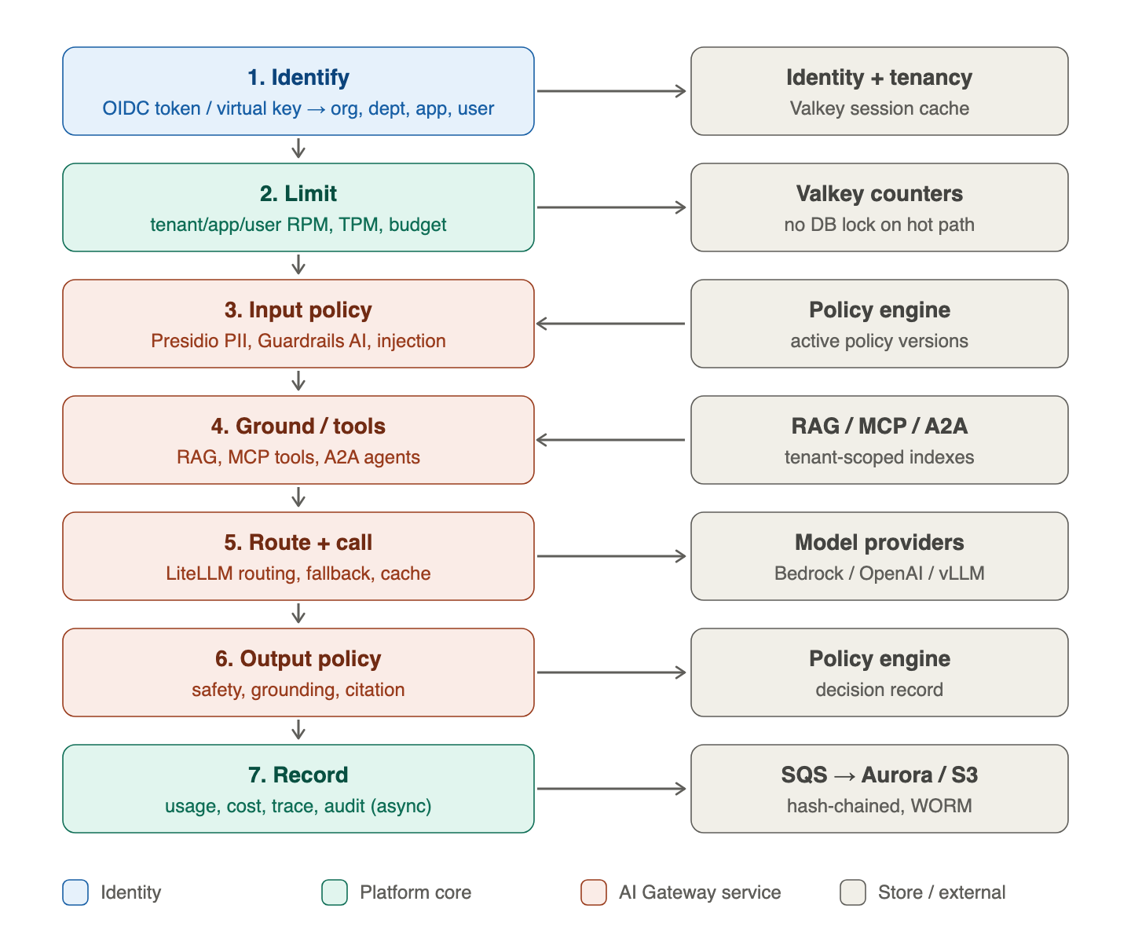
Figure 5 – Governed request flow through the AI Gateway

Request Segments: Runtime → Gateway → LLM Proxy → Provider
The AI Apps Platform runtime and the AI Gateway are separate components. The runtime makes no direct model calls; every model, embedding, rerank or MCP call goes through the gateway, and the LLM proxy (LiteLLM) is reachable only from the gateway. Detailed design: AI Gateway LiteLLM Tenant Isolation, Cache Policy and Analytics – Detailed Design v1.1.
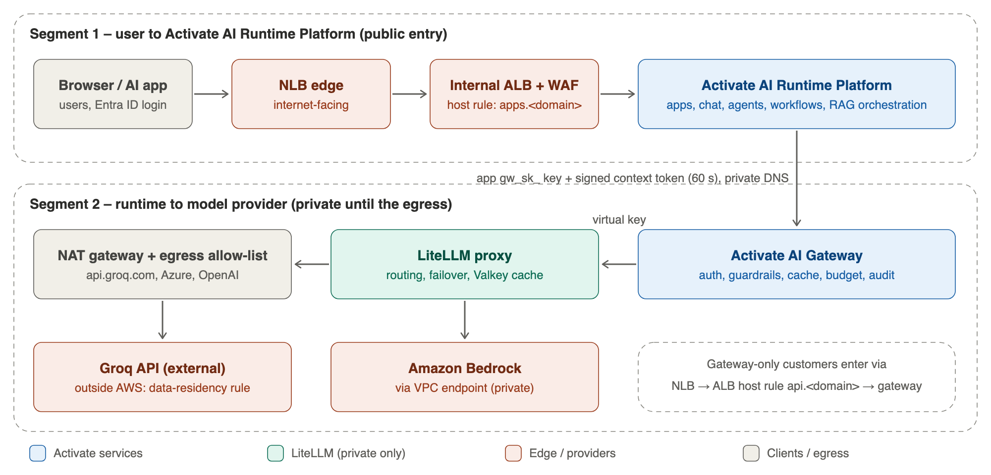
Figure 6 – Request segments and trust boundaries
Segment | Path | Controls
1 – user to runtime | Browser / AI app → NLB edge → internal ALB + WAF → AI Runtime Platform | Public entry; WAF; Entra ID sign-in and session
2a – runtime to gateway | Runtime → AI Gateway over private DNS (no public route) | App gateway key (gw_sk_) + signed context token (60 s JWT, KMS-signed): org, department, app, hashed user, classification, trace ID; gateway checks the token against the key binding
2b – gateway to LLM proxy | AI Gateway → LiteLLM over private DNS; LiteLLM has no public load balancer or IP | App virtual key; tenant_guard hook rebuilds the cache namespace from the key
2c – proxy to provider | LiteLLM → Bedrock (VPC endpoint) or external providers such as Groq, Azure OpenAI, OpenAI (NAT + egress allow-list) | Provider keys in Secrets Manager; per-tenant and per-classification provider allow-list (residency)
Gateway-only customers | Customer app → NLB edge → ALB host rule api.<domain> → AI Gateway | gw_sk_ key; same gateway controls; LiteLLM still private

Control-Plane Integration: Discovery and Gateway-Issued Credentials
The AI App control plane integrates with the AI Gateway control plane at run time rather than by release: it reads a discovery document and an authenticated capability manifest, renders or embeds tenant-scoped gateway configuration from the manifest’s schemas, and obtains credentials for applications from the gateway. The gateway is the authority for model access: a tenant or application is served only after a gateway grant, enforced independently at the network, token and key layers. Detailed design: RESPONSIBLE-AI PROXY_MANAGER_ENTERPRISE_DESIGN.md §2 (R9).
Contract element | Design | Phase
Discovery document | /.well-known/ai-gateway: gateway version, OIDC issuer and JWKS, token and token-exchange endpoints, scopes, data-plane and management base URLs, capability manifest URL, UI embed URL, OpenAPI URL, event catalogue | Phase 0 †
Capability manifest | Authenticated; lists the sections and actions available to the calling principal and scope with routes, required scopes and JSON Schemas derived from LiteLLM metadata (/config/list, /cache/settings, /public/providers/fields, /openapi.json) and the settings catalogue; versioned with an ETag so new LiteLLM capabilities appear without an App-platform release | Phase 0 † (schemas extended in Phase 2 †)
Tenant onboarding = grant | Creates the tenant record and the LiteLLM organization; nothing is served before | Phase 0 (platform core)
Application registration | OAuth 2.0 client (client credentials, resource-server scopes gateway.inference, gateway.manage:tenant, gateway.manage:app, gateway.read:spend) and a LiteLLM virtual key created server-side and never disclosed; separate build-time (CI, SDK, evaluation) and run-time credentials with different scopes and budgets; auto-rotation | Phase 0 (runtime trust) and Phase 3 †
Token exchange | The App control plane acting for a tenant administrator exchanges its user token for a short-lived, KMS-signed gateway token carrying tenant, scopes and an act claim; validated against the App platform’s JWKS | Phase 3 †
Events | tenant.provisioned, app.registered, app.credential.issued | rotated | revoked, budget.threshold, model.added | deprecated, capabilities.changed over HMAC-signed webhooks or EventBridge | Phase 3 †
Three enforcement layers | Network (LiteLLM reachable only from the gateway), token validation plus tenant / application registry status and scopes, LiteLLM key state (blocked, expired, budget); revocation blocks the key and disables the client within seconds | Phase 0 onwards

App Build and Publish Flow
- 1. Maker creates an app from a template in App Studio (chat, agent or workflow) and binds knowledge, tools, model profile and guardrail profile.
- 2. Evaluation runs against a test set; results and policy checks are attached to the app version.
- 3. Department approver approves; the version is published to a URL (web / PWA) with its own virtual key and budget.
- 4. At runtime the app calls the Gateway (LLM, RAG, MCP, A2A); usage is billed to the app and department.

Agent-to-Agent Flow
- 1. An orchestrator agent discovers a target agent from the A2A registry (agent card, skills, auth scheme).
- 2. The A2A gateway authenticates both parties, applies tenant policy (allowed agents, data classification) and forwards the task.
- 3. Messages and artefacts are traced end to end and audited; cross-tenant calls require explicit consent on both sides.

2.8 Multi-Tenancy, Isolation and Scalability
How the platform isolates tenants and scales from 100 to 1,000 users or agents.
Layer | Pooled tier (default) | Silo tier (premium / regulated) | Dedicated (government)
Identity | Entra External ID, one organisation per tenant | Dedicated Entra tenant or app registration | Customer Entra ID
Compute | Shared namespaces; per-tenant limits | Dedicated node group or cluster | Customer cluster
Database | Shared Aurora; RLS enforced with a non-owner role, fail-closed; org_id foreign keys | Dedicated Aurora cluster | Customer database
Encryption | Per-tenant KMS data keys for S3 and secrets | Customer-managed KMS key | Customer KMS / HSM
Models | Per-tenant Bedrock inference profile and token quotas | Provisioned throughput | Customer account or vLLM
Noisy-neighbour control | Valkey token buckets per org/app/user/key (RPM, TPM, concurrent streams) | Dedicated quotas | N/A

Capacity Model
Dimension | 100 users | 1,000 users | 1,000 agents
Concurrent requests | 10–20 | 100–200 | ≈ 150 req/s sustained
Gateway pods (0.5 vCPU, async) | 2–3 | 6–10 | 20–30
Agent-runtime pods | 1–2 | 3–5 | 15–25 + SQS backlog
Aurora | 2–4 ACU, 1 writer | 4–16 ACU + reader + RDS Proxy | 8–32 ACU + reader + RDS Proxy; partitioned usage tables
Valkey | 1 primary + replica | 3-shard cluster | 3–6-shard cluster
Model quota | Default on-demand | Raised TPM quotas | Provisioned throughput / multi-provider routing
- Hot path is lock-free: budget and quota checks use Valkey counters; usage and audit rows are written by an asynchronous writer, removing the per-tenant advisory locks of the as-built gateway.
- Scoped settings: gateway settings resolve org → department → app → key with narrow-only inheritance (a lower scope may only restrict models, budgets, timeouts and guardrails unless the parent marks a setting delegable); proxy-global settings such as the cache backend and master key are locked at platform scope. Each scope maps to a LiteLLM organization, team or virtual key, so budgets, limits and model scope are enforced by the proxy at every level.
- Per-tenant rate rules replace the per-IP WAF limit for authenticated API traffic, so agents behind one NAT address are not throttled.
- Background jobs move to Kubernetes CronJobs / leader-elected workers so scaling out does not duplicate them.
- Latency budget (p95, excluding model time): auth + limits < 10 ms; input policy < 40 ms (Presidio + Guardrails regex tier); RAG < 60 ms; output policy < 30 ms – total < 150 ms at GA 1.0, < 100 ms at GA 2.0 with policy caching.

2.9 Availability
- SaaS: multi-AZ for every tier; Aurora with reader failover; Valkey cluster with replicas; NAT per AZ; 99.5% at GA 1.0 and 99.9% at GA 2.0.
- Disaster recovery: cross-region Aurora global database and S3 replication within the same country where residency requires; RPO 15 minutes, RTO 4 hours (GA 2.0).
- LLM inference availability is managed by the AI Gateway LLM proxy: health-checked routing across providers and regions, automatic fallback, per-tenant quotas and provisioned capacity – the platform does not depend on any single provider or region.
- Release rings (internal → canary tenants → all) with automatic rollback on SLO breach.

2.10 Supportability and Maintainability
☒ Solution supported and maintained by a third party outside the organization (Activate Interactive).
- SLOs, dashboards and alerts per tenant; runbooks for restore, key rotation, tenant export and incident response.
- Monthly releases; on-prem and air-gapped customers receive the same release as signed Helm bundles.
- Upstream tracking for LiteLLM, Activepieces CE and LangGraph with a quarterly upgrade window and contract tests.

3 Security and Compliance

3.1 Responsible AI Pillars
Pillars from the RESPONSIBLE-AI-ENTERPRISEREADY project, mapped to gateway enforcement and tools.
Pillar | Gateway enforcement | Open-source / AWS tools
Privacy | PII detection and redaction before and after model calls; hashed prompts in audit | Microsoft Presidio (+ regex fallback), Bedrock Guardrails sensitive-info filters
Safety | Input/output validation, harmful content, fraud, injection and jailbreak detection; versioned policies | Guardrails AI + Hub validators, Bedrock Guardrails, garak / PyRIT red-team
Fairness | Bias test sets per app; group-level outcome metrics | Ragas, custom evaluators
Explainability | Citations, reasoning traces, decision records | TruLens, Langfuse traces
Verifiability | Grounding checks against retrieved sources; evaluation gates before publish | Ragas, TruLens
Transparency | End-to-end traces, model and policy version on every response | OpenTelemetry, Langfuse, Jaeger
Governance | Policy lifecycle draft → review → approved → active → deprecated; external sources (Guardrails Hub, NIST, OWASP) enter as draft only; change audit | Policy engine (from RESPONSIBLE-AI project), PostgreSQL
Controllability | Human-in-the-loop approvals, kill switch per app/agent, budgets, tool ACLs | Policy engine, LangGraph interrupts, Activepieces approvals

3.2 Compliance Frameworks
Framework | Scope | How the platform supports it
SOC 2 (Type I → Type II) | Activate SaaS operations | Control mapping, automated evidence (access reviews, change logs, backups, vulnerability scans); Type I audit after Phase 4 (backlog)
NIST AI RMF 1.0 + Generative AI Profile (AI 600-1) | Customer AI systems | Govern/Map/Measure/Manage evidence from policy engine, evaluations and audit
ISO/IEC 42001 | AI management system | Readiness after Phase 4; same evidence base
Singapore IM8 and Model AI Governance Framework for GenAI; AI Verify | Singapore government and regulated sectors | IM8 control mapping, data classification up to RESTRICTED / SENSITIVE NORMAL on GCC, AI Verify test export
Malaysia | PDPA 2010 (2024 amendments); National Guidelines on AI Governance and Ethics | In-country hosting (ap-southeast-5), consent and breach-notification support
Thailand | PDPA 2019; ETDA AI governance guidance | In-country hosting (ap-southeast-7), data-subject request tooling
Indonesia | Personal Data Protection Law No. 27/2022; AI ethics circular | In-country hosting (ap-southeast-3), residency enforcement
Vietnam, Philippines | Decree 13/2023; Data Privacy Act 2012 | Country packs in later releases
Compliance packs are configuration bundles (policies, retention, residency, evidence reports) applied per organisation; legal interpretation remains with the customer.

3.3 User Security
☒ User authentication delegated to Identity and Access Management (IAM) systems. Microsoft Entra ID (Azure AD) is the identity platform; Entra External ID federates customer providers over OIDC or SAML (Okta, Google, Ping, Singpass / Corppass for government services); SCIM provisioning; Keycloak for air-gapped sites.
☒ User authorization managed by the solution. RBAC + ABAC across organisation, department and app; approvals for publish and policy activation.

3.4 Integration Security
- Outbound application-to-application calls (AWS, Azure, SAP, REST) use credentials held in KMS-encrypted vault entries scoped to an app; the integration hub obtains short-lived credentials (AWS STS AssumeRole with external ID, Azure workload identity federation, SAP OAuth) and calls through the egress proxy with per-tenant allow-lists. SSRF protection on all user-supplied URLs.
- Runtime to gateway: each app calls with its own gateway key plus a short-lived signed context token (KMS-signed JWT carrying org, department, app, hashed user, classification and trace ID); the gateway rejects tokens that do not match the key’s binding, expired tokens and replays.
- Control-plane access: tenants and applications are served only after a gateway grant. Applications receive OAuth 2.0 client credentials from the gateway (separate build-time and run-time credentials, auto-rotated) while the LiteLLM virtual key stays inside the gateway; the App control plane acts for a tenant administrator only through gateway token exchange. Enforcement is independent at the network, token / registry and key layers, so a misconfiguration in one layer does not open the proxy.
- MCP: OAuth 2.1 per server, tool-level ACLs per tenant/app, tool calls audited and policy-checked.
- A2A: agent identity via signed agent cards, OAuth 2.0 client credentials or mTLS; cross-tenant calls require bilateral consent.
- Supply chain: signed images (cosign), SBOMs, dependency and container scanning, secret scanning in CI (closing the as-built critical finding).

3.5 Network Security
- Private subnets for all compute and data; VPC endpoints for AWS services; egress proxy for internet calls.
- Only two public entry points: the AI Runtime Platform (apps host) and the AI Gateway API (api host) for gateway-only customers. The LLM proxy (LiteLLM), MCP servers, workers and admin APIs are private; LiteLLM admits traffic only from the gateway and the tenancy sync worker.
- Runtime-to-gateway calls use private DNS; network policies (EKS) or security groups (ECS) allow only runtime workloads to reach the gateway’s internal port.
- External model providers (for example Groq) are reached through the egress allow-list only and are allowed per tenant and data classification; residency-bound and GCC tenants never use them, including in failover.
- Kubernetes network policies isolate product namespaces; service mesh mTLS (optional) between services.
- WAF with managed rules, bot control on public apps, per-tenant rate rules.

3.6 Sensitive Data Protection
- Encryption at rest with per-tenant keys; TLS 1.2+ in transit.
- PII redaction before any external model call; tenant option to block external providers for classified data.
- Data residency enforced by region pinning per organisation and model routing rules (no global inference profiles for residency-bound tenants).
- Retention policies per tenant; export and deletion on off-boarding.

4 Technical Debt and Exceptions to Standards

4.1 Carried Forward from the As-Built Gateway
Item | Resolution | Release
Committed secrets in git | Rotate, purge history, secret scanning | Phase 0 (recommended addition)
RLS not enabled; policy fails open | Enforce with non-owner role, fail-closed, org_id FKs | Phase 0 (recommended addition)
Per-tenant locks on budget and audit | Valkey counters + asynchronous writer | Phase 1 (with granular budget controls)
Bedrock-only models; global inference profile | LiteLLM proxy; in-region profiles | Phase 0 (provider abstraction)
Response cache does not scale (no purge, shared IVFFlat index, double embedding, writer hot rows, organisation-only scope) | Valkey exact tier, HNSW with iterative scan, partition purge, upsert, policy-driven scope (detailed design §5.6) | Phase 2 (addition †)
Gateway reachable only through the public ALB (no private DNS for internal callers) | Enable private service discovery for the gateway; runtime calls it privately with gateway key + signed context token | Phase 0 (addition †)
ECS-only packaging | EKS + Helm | After Phase 4 (backlog)
Entra ID sign-in is single-tenant (one app registration); RBAC and ABAC already implemented | Keep as the base; add multi-tenant federation (Entra External ID, other IdPs) and SCIM | After Phase 4 (backlog)
Logical-only relationships (DM-1 to DM-10) | Constraint migrations | Phase 0 (platform core, tenant and admin portal)
LiteLLM refuses runtime changes to settings pinned in its config file | Bootstrap-only config file (models, keys, database, OTel); router, LiteLLM, cache and general settings held in the proxy database and seeded from versioned defaults (reference implementation) | Phase 1 (gateway admin console †)

4.2 Licensing Considerations
Component | Licence | Position
Activepieces | MIT (core); commercial for packages/ee and server/api/src/app/ee | Use CE; licence agreement handled as a separate track (Appendix E)
LiteLLM | MIT (core); enterprise directory commercial | Use OSS proxy; licence agreement handled as a separate track (Appendix E)
LangGraph, Presidio, Guardrails AI, TruLens, Ragas, Langfuse, Keycloak, vLLM | MIT / Apache 2.0 | Track licences in the SBOM

5 Assumptions, Dependencies and Open Items

5.1 Assumptions and Dependencies
- Start date 2 November 2026; delivery in five phases (Phase 0 – Phase 4, November 2026 – March 2027) using the Activate phased-deliverable format (Appendices A and B), followed by the product-vision backlog (Appendix C).
- Existing AI Gateway code, RESPONSIBLE-AI project and NEA Local POC are owned by Activate and may be reused.
- AI coding agents (e.g. Claude Code) are approved for use on the codebase with architect review and security scanning (Appendix C.4).
- LLM inference availability is managed by the AI Gateway LLM proxy (multi-provider, multi-region routing), so regional model availability is a routing configuration, not a dependency.
- Bespoke AI apps and their models remain in their owners’ environments and are onboarded through the SDK and APIs; only third-party model provider interfaces pass through the AI Gateway. The platform does not host GPU-driven models.
- Licence agreements for Activepieces and LiteLLM are handled as a separate commercial track (Appendix E).

5.2 Open Items
# | Open item | Owner
1 | Validate the recommended three-tier pricing (section 1.9) with the first two or three design-partner customers. | Product
2 | Entra External ID licensing model and cost per monthly active user at GA 2.0 volumes. | Architecture
3 | SOC 2 auditor selection and observation-period start. | Compliance
4 | Onboarding SDK and minimum integration level for bespoke apps such as NEA Local POC. | Architecture
5 | Telemetry contract for bespoke-model apps (traces, usage, audit events) so they stay visible without routing through the gateway. | Architecture
6 | LiteLLM Enterprise-only features (key regenerate, some admin fields, SSO): licence or gateway-side equivalents (the reference implementation rotates keys gateway-side). | Architecture / Legal
7 | Organization-level budgets in open-source LiteLLM: spike before scoped settings (Phase 2); fallback is tenant = team, department = key groups with tags. | Architecture

Appendix A Phased Roadmap
Activate phased-deliverable format. AI Gateway view: gateway features plus its share of shared-core and continuous design and testing effort. The combined view for both products is in the Activate AI Platform Overall Roadmap.
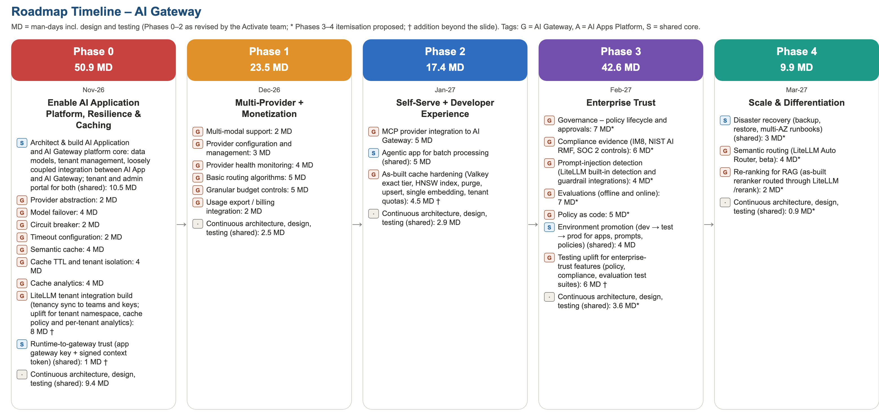
Figure 7 – Phased roadmap, AI Gateway view (* = proposed itemisation; † = addition beyond the slide)

Phase 0 – Enable AI Application Platform, Resilience & Caching (Nov-26)
# | Feature | Product | Design | Development | Testing | Product mgmt | Total MD
1 | Architect & build AI Application and AI Gateway platform core: data models, tenant management, loosely coupled integration between AI App and AI Gateway; tenant and admin portal for both | Shared core | 2 | 6.5 | 2 | – | 10.5
2 | Provider abstraction | AI Gateway | 0 | 1 | 1 | – | 2
3 | Model failover | AI Gateway | 0 | 2 | 2 | – | 4
4 | Circuit breaker | AI Gateway | 0 | 1 | 1 | – | 2
5 | Timeout configuration | AI Gateway | 0 | 1 | 1 | – | 2
6 | Semantic cache | AI Gateway | 0 | 2 | 2 | – | 4
7 | Cache TTL and tenant isolation | AI Gateway | 0 | 2 | 2 | – | 4
8 | Cache analytics | AI Gateway | 0 | 2 | 2 | – | 4
9 | LiteLLM tenant integration build (tenancy sync to teams and keys; uplift for tenant namespace, cache policy and per-tenant analytics) † | AI Gateway | 0 | 6.5 | 1.5 | – | 8
10 | Runtime-to-gateway trust (app gateway key + signed context token) † | Shared core | 0 | 0.8 | 0.3 | – | 1.1
11 | AI App–AI Gateway integration contract: /.well-known/ai-gateway discovery document and authenticated capability manifest (sections, routes, scopes, JSON Schemas) for runtime discovery; tenant onboarding as the gateway grant † | Shared core | 0.5 | 1 | 0.5 | – | 2
12 | Continuous architecture, design, testing | Shared (continuous) | 4.7 | 0 | 4.7 | – | 9.4
 | Product management (10% of phase effort) | Programme | – | – | – | 5.3 | 5.3
 | Phase total |  | 7.2 | 25.8 | 20 | 5.3 | 58.3

Phase 1 – Multi-Provider + Monetization (Dec-26)
# | Feature | Product | Design | Development | Testing | Product mgmt | Total MD
1 | Multi-modal support | AI Gateway | 0 | 1 | 1 | – | 2
2 | Provider configuration and management | AI Gateway | 0 | 1 | 2 | – | 3
3 | Provider health monitoring | AI Gateway | 0 | 2 | 2 | – | 4
4 | Basic routing algorithms | AI Gateway | 0 | 3 | 2 | – | 5
5 | Granular budget controls | AI Gateway | 1 | 3 | 1 | – | 5
6 | Usage export / billing integration | AI Gateway | 0 | 1 | 1 | – | 2
7 | Gateway admin console (Proxy Manager): providers, models and prices, credentials (Secrets Manager or LiteLLM encrypted store), keys and teams with budgets and rotation, MCP servers, proxy guardrails, routing / fallback / cache / general settings held in the proxy database; audited, allow-listed passthrough – port of the RESPONSIBLE-AI reference implementation † | AI Gateway | 0.5 | 4 | 1.5 | – | 6
8 | Continuous architecture, design, testing | Shared (continuous) | 0.9 | 0.6 | 0.9 | – | 2.4
 | Product management (10% of phase effort) | Programme | – | – | – | 2.9 | 2.9
 | Phase total |  | 2.4 | 15.6 | 11.4 | 2.9 | 32.3

Phase 2 – Self-Serve + Developer Experience (Jan-27)
# | Feature | Product | Design | Development | Testing | Product mgmt | Total MD
1 | MCP provider integration to AI Gateway | AI Gateway | 0 | 4 | 1 | – | 5
2 | Agentic app for batch processing | Shared core | 0 | 3.5 | 1.5 | – | 5
3 | As-built cache hardening (Valkey exact tier, HNSW index, purge, upsert, single embedding, tenant quotas) † | AI Gateway | 0 | 3.5 | 1 | – | 4.5
4 | Scoped gateway settings: org → department → app → key with narrow-only inheritance and locks; scope switcher in the admin console; mapped to LiteLLM organization / team / key (router settings, guardrails, tags, callbacks, budgets) † | AI Gateway | 1 | 5 | 2 | – | 8
5 | Guided configuration: settings catalogue with recommended values per environment and workload, pre-save validation, configuration profiles with diff preview † | AI Gateway | 1 | 3 | 1 | – | 5
6 | LiteLLM capability discovery: manifest from /routes and OpenAPI, coverage status, upgrade diff with audit, admin-enabled allow-list (inference routes excluded), schema-driven explorer † | AI Gateway | 0 | 3 | 1 | – | 4
7 | Continuous architecture, design, testing | Shared (continuous) | 1 | 0.7 | 1.3 | – | 3
 | Product management (10% of phase effort) | Programme | – | – | – | 3.5 | 3.5
 | Phase total |  | 3 | 22.7 | 8.8 | 3.5 | 38

Phase 3 – Enterprise Trust (Feb-27)
# | Feature | Product | Design | Development | Testing | Product mgmt | Total MD
1 | Governance – policy lifecycle and approvals * | AI Gateway | 0 | 7 | 0 | – | 7
2 | Compliance evidence (IM8, NIST AI RMF, SOC 2 controls) * | AI Gateway | 0 | 6 | 0 | – | 6
3 | Prompt-injection detection (LiteLLM built-in detection and guardrail integrations) * | AI Gateway | 0 | 3 | 1 | – | 4
4 | Evaluations (offline and online) * | AI Gateway | 0 | 7 | 0 | – | 7
5 | Policy as code * | AI Gateway | 0 | 5 | 0 | – | 5
6 | Environment promotion (dev → test → prod for apps, prompts, policies) | Shared core | 0 | 4 | 0 | – | 4
7 | Testing uplift for enterprise-trust features (policy, compliance, evaluation test suites) † | AI Gateway | 0 | 0 | 6 | – | 6
8 | Build-time and run-time app credentials (client credentials for CI, SDK and evaluation pipelines), gateway token exchange for the App control plane acting for a tenant administrator, gateway events (webhooks / EventBridge) † | Shared core | 0.5 | 2 | 0.5 | – | 3
9 | Admin audit view: gateway configuration changes (providers, models, keys, settings, rotations, seeding) with tenant scope † | AI Gateway | 0 | 1.5 | 0.5 | – | 2
10 | Continuous architecture, design, testing * | Shared (continuous) | 1.5 | 0 | 2.2 | – | 3.7
 | Product management (10% of phase effort) | Programme | – | – | – | 4.8 | 4.8
 | Phase total |  | 2 | 35.5 | 10.2 | 4.8 | 52.5

Phase 4 – Scale & Differentiation (Mar-27)
# | Feature | Product | Design | Development | Testing | Product mgmt | Total MD
1 | Disaster recovery (backup, restore, multi-AZ runbooks) * | Shared core | 0 | 3 | 0 | – | 3
2 | Semantic routing (LiteLLM Auto Router, beta) * | AI Gateway | 0 | 3 | 1 | – | 4
3 | Re-ranking for RAG (as-built reranker routed through LiteLLM /rerank) * | AI Gateway | 0 | 1.5 | 0.5 | – | 2
4 | Configuration copilot: propose-only assistant grounded in the settings catalogue, LiteLLM docs, effective configuration and FinOps / AIOps signals; reviewable diffs applied only after approval; evaluated with Ragas † | AI Gateway | 1 | 5 | 2 | – | 8
5 | Continuous architecture, design, testing * | Shared (continuous) | 0.4 | 0 | 0.5 | – | 0.9
 | Product management (10% of phase effort) | Programme | – | – | – | 1.8 | 1.8
 | Phase total |  | 1.4 | 12.5 | 4 | 1.8 | 19.7

Appendix B Resource Requirement by Phase
Man-days (MD) by discipline. Development = feature effort from the roadmap slide; design and testing = the slide’s continuous architecture, design and testing effort (40% / 60%); product management = 10% added on top of each phase.

B.1 AI Gateway Resource Requirement
Discipline | Phase 0 (Nov-26) | Phase 1 (Dec-26) | Phase 2 (Jan-27) | Phase 3 (Feb-27) | Phase 4 (Mar-27) | Total MD
Design (architecture, solution and UX design) | 7.2 | 2.4 | 3 | 2 | 1.4 | 16
Development | 25.8 | 15.6 | 22.7 | 35.5 | 12.5 | 112.1
Testing (QA, automation, performance, security) | 20 | 11.4 | 8.8 | 10.2 | 4 | 54.4
Product management | 5.3 | 2.9 | 3.5 | 4.8 | 1.8 | 18.3
Total | 58.3 | 32.3 | 38 | 52.5 | 19.7 | 200.8
Indicative team (FTE over 20 working days) | 2.9 | 1.6 | 1.9 | 2.6 | 1 | 2

B.2 Slide Reconciliation
Phase | Slide header MD | Itemised MD used | Difference | Note
Phase 0 | 50 | 69 | 19 | Revised by the Activate team: platform core now includes tenant management and the tenant and admin portal for both products; per-feature testing added. Plus † LiteLLM tenant integration build (8 MD) and runtime–gateway trust (2 MD). Plus † from the RESPONSIBLE-AI-ENTERPRISEREADY roadmap review (2 October 2026): AI App–AI Gateway integration contract (4 MD)
Phase 1 | 52 | 82 | 30 | Revised by the Activate team: per-feature testing; generic knowledge and analytics tools moved in (23 MD, previously a Horizon 1 addition). Plus † gateway admin console – Proxy Manager (6 MD, port of the RESPONSIBLE-AI reference implementation)
Phase 2 | 50 | 70.5 | 20.5 | Revised by the Activate team: LangGraph agentic workflows and an agentic batch-processing app replace the NEA port (moved to Phase 4) and the tenant portal (moved to Phase 0). Plus † as-built cache hardening (4.5 MD). Plus † scoped gateway settings (8 MD), guided configuration (5 MD) and LiteLLM capability discovery (4 MD)
Phase 3 | 40 | 55 | 15 | Breakdown proposed (*); environment promotion 8 MD per the Activate team; prompt-injection detection revised to 4 MD (LiteLLM built-in detection). Plus † testing uplift (6 MD). Plus † app credentials, token exchange and gateway events (6 MD) and admin audit view (2 MD)
Phase 4 | 30 | 53 | 23 | Breakdown proposed (*); semantic routing revised to 4 MD and re-ranking to 2 MD (LiteLLM Auto Router and /rerank); NEA port moved in (10 MD). Plus † agent–workflow interoperability (9 MD). Plus † configuration copilot (8 MD)

B.3 Backlog After Phase 4 (AI Gateway and shared core)
Capability not covered by Phases 0–4 | Product | Indicative MD
Critical security fixes from the as-built review (secret rotation and history purge, enforced fail-closed RLS, CI secret scanning) – recommended to add to Phase 0 | Shared core | 4
Identity: multi-tenant Entra federation (External ID, other IdPs), SCIM, group-to-role mapping – extends the as-built Entra ID login and RBAC/ABAC | Shared core | 10
A2A gateway (agent cards, auth, routing) | AI Gateway | 30
Compliance packs for Malaysia, Thailand, Indonesia; SOC 2 Type I audit support | AI Gateway | 90
EKS + Helm packaging; on-premises and air-gapped bundles | Shared core | 55
Scale to 1,000 users / agents (asynchronous usage and audit writers, Valkey counters, load tests) | Shared core | 17.5
Dedicated LiteLLM proxy instance per silo tenant (own database, secret manager and cache namespace; isolation tier T2 in the RESPONSIBLE-AI multi-tenancy design) | AI Gateway | 12
Total (indicative) |  | 218.5
Phases 0–4 need about 200.8 MD for the AI Gateway share (including product management), of which 41.8 MD are the additions from the RESPONSIBLE-AI roadmap review. The backlog adds about 218.5 MD (indicative, AI-assisted, including 20% buffer) to reach the full gateway vision in Appendix C. Shared-core items are split 50/50 with the AI Apps Platform.

Appendix C Full Product Vision – Release Train and Effort (Reference)
Reference only: the complete product vision (all deployment modes, compliance packs, bespoke app onboarding, scale to 1,000 agents) as a twelve-release train, with effort for manual and AI-assisted delivery. Phases 0–4 (Appendices A and B) deliver the first, committed subset; the backlog in Appendix B.3 bridges to this vision.
Twelve monthly releases from November 2026 to October 2027. Each release is two two-week sprints: sprint 1 builds, sprint 2 hardens, tests and releases.
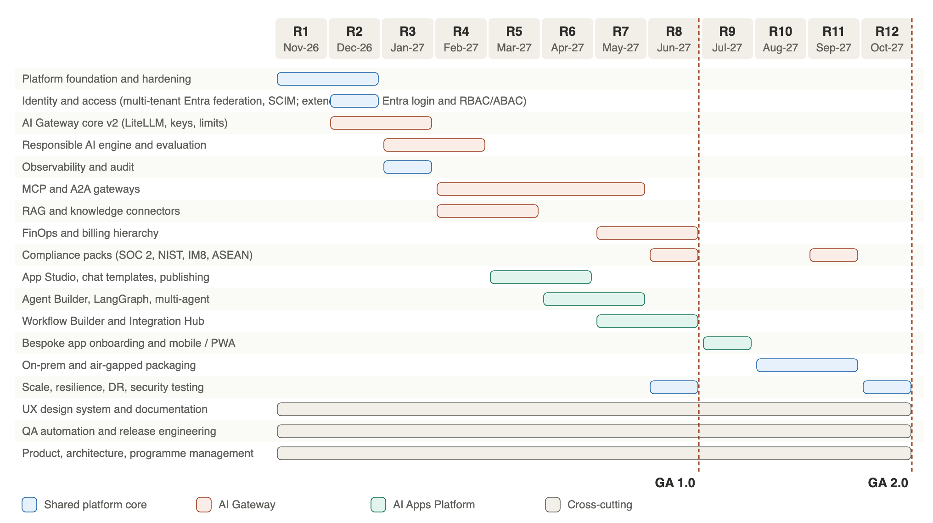
Figure 8 – Product vision release train by workstream
Release | Month | Theme | Scope | Exit criteria
R1 | Nov-26 | Foundation | Fix critical findings (secret rotation, fail-closed RLS, budget/audit off hot path); EKS + Helm baseline; tenancy hierarchy org → dept → app → user; CI/CD with OIDC and signed images | Critical findings closed; EKS staging live
R2 | Dec-26 | Identity + Gateway v2 | OIDC federation to any provider + SCIM; RBAC/ABAC per org/dept; LiteLLM proxy (multi-provider, virtual keys, fallbacks); per-tenant RPM/TPM limits in Valkey | Any OIDC IdP; multi-provider models
R3 | Jan-27 | Responsible AI + observability | Responsible AI engine (Presidio, Guardrails AI, policy lifecycle draft → active); Langfuse + OpenTelemetry end to end; WORM audit (S3 Object Lock); metering events | Eight pillars active; traces end to end
R4 | Feb-27 | Tools and agent protocols | MCP Gateway v2 (OAuth, tool ACLs); A2A Gateway alpha (agent cards, auth); RAG connectors (SharePoint, S3); evaluation (TruLens, Ragas) | MCP OAuth; A2A demo; connectors
R5 | Mar-27 | Apps Platform alpha | App Studio; templated chat apps; chat app builder; publish as web app / PWA; template library | First chat app published
R6 | Apr-27 | Agentic apps | Agent Builder on LangGraph; agent templates; human-in-the-loop; multi-agent orchestrator with chat UI (alpha) | First agent app with HITL
R7 | May-27 | Workflows + integration | Workflow Builder (Activepieces CE engine, with or without chat); Integration Hub for AWS, Azure, SAP, REST via egress proxy and credential vault; A2A beta | Workflow with and without chat; SAP/AWS/Azure call
R8 | Jun-27 | GA 1.0 – SaaS Singapore | FinOps billing by org/dept/app/user with invoice export; compliance pack 1 (SOC 2 controls, NIST AI RMF, IM8); pooled + silo SaaS; penetration test; GA 1.0 | GA 1.0: first paying tenants in Singapore
R9 | Jul-27 | BYOA + mobile | Bespoke AI app onboarding (SDK, identity and gateway integration); onboard NEA Local POC; mobile packaging of PWA; template marketplace | NEA POC onboarded (sign-in, gateway, audit)
R10 | Aug-27 | On-premises | Helm for OpenShift / RKE2 / EKS Anywhere; Keycloak, CloudNativePG, MinIO, NATS adapters; vLLM local models | On-prem install in < 1 day
R11 | Sep-27 | Air-gapped + ASEAN | Air-gapped bundle (Harbor, signed offline updates, offline evals); compliance packs Malaysia, Thailand, Indonesia (+ Vietnam, Philippines); in-country AWS regions | Air-gapped install verified; ASEAN regions
R12 | Oct-27 | Scale + GA 2.0 | 1,000 users / agents load and soak tests; multi-AZ + DR; SOC 2 Type I audit; ISO/IEC 42001 readiness; GA 2.0 across all deployment modes | GA 2.0: 1,000 agents at SLO; SOC 2 Type I report

C.2 Vision Effort Estimate and Resource Plan
Man-days (MD) for the entire roadmap. A 20% buffer is added to every line item.

C.2.1 Manual Coding
# | Workstream | Releases | Base MD | +20% | Total MD
1 | Platform foundation and hardening | R1–R2 | 120 | 24 | 144
2 | Identity and access (multi-tenant Entra federation, SCIM; extends as-built Entra login and RBAC/ABAC) | R2 | 50 | 10 | 60
3 | AI Gateway core v2 (LiteLLM, keys, limits) | R2–R3 | 110 | 22 | 132
4 | Responsible AI engine and evaluation | R3–R4 | 120 | 24 | 144
5 | Observability and audit | R3 | 70 | 14 | 84
6 | MCP and A2A gateways | R4–R7 | 100 | 20 | 120
7 | RAG and knowledge connectors | R4–R5 | 90 | 18 | 108
8 | FinOps and billing hierarchy | R7–R8 | 70 | 14 | 84
9 | Compliance packs (SOC 2, NIST, IM8, ASEAN) | R8–R11 | 100 | 20 | 120
10 | App Studio, chat templates, publishing | R5–R6 | 180 | 36 | 216
11 | Agent Builder, LangGraph, multi-agent | R6–R7 | 200 | 40 | 240
12 | Workflow Builder and Integration Hub | R7–R8 | 150 | 30 | 180
13 | Bespoke app onboarding and mobile / PWA | R9 | 50 | 10 | 60
14 | On-prem and air-gapped packaging | R10–R11 | 140 | 28 | 168
15 | Scale, resilience, DR, security testing | R8–R12 | 90 | 18 | 108
16 | UX design system and documentation | R1–R12 | 110 | 22 | 132
17 | QA automation and release engineering | R1–R12 | 140 | 28 | 168
18 | Product, architecture, programme management | R1–R12 | 220 | 44 | 264
 | Total |  | 2110 | 422 | 2532

C.2.2 AI Coding Agents with Architect Oversight
# | Workstream | Releases | Base MD | +20% | Total MD
1 | Platform foundation and hardening | R1–R2 | 78 | 15.6 | 93.6
2 | Identity and access (multi-tenant Entra federation, SCIM; extends as-built Entra login and RBAC/ABAC) | R2 | 28 | 5.6 | 33.6
3 | AI Gateway core v2 (LiteLLM, keys, limits) | R2–R3 | 61 | 12.2 | 73.2
4 | Responsible AI engine and evaluation | R3–R4 | 66 | 13.2 | 79.2
5 | Observability and audit | R3 | 42 | 8.4 | 50.4
6 | MCP and A2A gateways | R4–R7 | 55 | 11 | 66
7 | RAG and knowledge connectors | R4–R5 | 50 | 10 | 60
8 | FinOps and billing hierarchy | R7–R8 | 39 | 7.8 | 46.8
9 | Compliance packs (SOC 2, NIST, IM8, ASEAN) | R8–R11 | 85 | 17 | 102
10 | App Studio, chat templates, publishing | R5–R6 | 90 | 18 | 108
11 | Agent Builder, LangGraph, multi-agent | R6–R7 | 100 | 20 | 120
12 | Workflow Builder and Integration Hub | R7–R8 | 83 | 16.6 | 99.6
13 | Bespoke app onboarding and mobile / PWA | R9 | 30 | 6 | 36
14 | On-prem and air-gapped packaging | R10–R11 | 91 | 18.2 | 109.2
15 | Scale, resilience, DR, security testing | R8–R12 | 63 | 12.6 | 75.6
16 | UX design system and documentation | R1–R12 | 66 | 13.2 | 79.2
17 | QA automation and release engineering | R1–R12 | 84 | 16.8 | 100.8
18 | Product, architecture, programme management | R1–R12 | 198 | 39.6 | 237.6
 | Total |  | 1309 | 261.8 | 1570.8

C.3 Summary and Resource Plan
Approach | Base MD | With 20% buffer | Average FTE over 12 months | Saving
Manual coding | 2110 | 2532 | 10.6 | –
AI coding agents with architect oversight | 1309 | 1570.8 | 6.5 | 38%
Role | Manual (FTE) | AI-assisted (FTE) | Notes
Product owner | 1 | 1
Solution / AI architect | 1 | 1
Tech lead (gateway / platform) | 1 | 1
Backend engineers (Python, TypeScript) | 3 | 1.5 | AI agents generate services, tests and migrations; engineers review and integrate
Frontend engineers | 1.5 | 0.75
DevSecOps / platform engineer | 1 | 0.75
AI / ML engineer (Responsible AI, evals) | 1 | 0.5
QA automation engineer | 1 | 0.5 | AI agents generate Playwright/pytest suites; QA owns strategy and gates
UX designer | 0.5 | 0.5
GRC / compliance analyst | 0.5 | 0.5 | Evidence automation; auditor liaison
Technical writer | 0.3 | 0.2
Total | 11.8 | 8.2 | Peak in R5–R8; on-prem / air-gapped specialists join in R10–R11
The role plan (≈ 11.8 FTE manual, ≈ 8.2 FTE AI-assisted) is the peak team; it sits 10–20% above the effort-derived averages (≈ 10.6 and ≈ 6.5 FTE over 240 working days) because R5–R8 build both products in parallel, while R1–R2 and R11–R12 run lighter.

C.4 Delivery Model with AI Coding Agents
Practice | How AI agents are used | Human control
Spec-driven development | Agents draft ADRs, API contracts (OpenAPI), data migrations and test plans from the architecture spec | Architect approves every spec before code
Implementation | Agents implement services, UI components, Terraform/Helm and connectors in feature branches | Code review by an engineer; no direct pushes to main
Testing | Agents generate unit, contract, Playwright and k6 tests; mutation testing on critical modules | QA owns coverage gates and test data
Security | Agents triage SAST/DAST/dependency findings and propose fixes | Security review for auth, crypto, tenancy and policy code
Documentation | Agents keep architecture docs, runbooks and API docs in sync with code | Technical writer review per release
Governance | Agent usage logged; prompts exclude customer data and secrets | Approved tool list; licence and IP checks
Savings are largest on application code, UI and tests (about 50%), lower on infrastructure (35%) and smallest on compliance and programme management (10–15%), which depend on people, auditors and customers.

Appendix D Indicative SaaS Infrastructure Cost
Pooled SaaS region (Singapore), monthly, on-demand, USD, excluding model tokens and support.
Item | 100 users (GA 1.0 tenant) | 1,000 users / agents (GA 2.0) | Notes
EKS control plane + nodes | ≈ $500 | ≈ $1,200 | Graviton nodes; Karpenter right-sizing
Aurora PostgreSQL (+ reader, RDS Proxy) | ≈ $300 | ≈ $1,850 | Serverless v2, 2 → 12 ACU average
ElastiCache Valkey | ≈ $50 | ≈ $450 | 1 node → 3-shard cluster
Load balancing, WAF, CloudFront | ≈ $70 | ≈ $200
NAT (per AZ) + egress proxy | ≈ $100 | ≈ $200
Observability (AMP, Grafana, Langfuse, logs) | ≈ $150 | ≈ $600 | Scales with trace volume
S3, KMS, Secrets, SQS, backups | ≈ $50 | ≈ $150
Total (indicative) | ≈ $1,200 / month | ≈ $4,650 / month | Shared across tenants in the pooled tier
Model tokens are additional and pass through to tenants via FinOps: at the PA POC profile (≈ 22,000 turns a month) Claude Sonnet-class tokens cost ≈ US$2,900 a year per 100 users; agent workloads can be 10–50× higher and should use routing to smaller models and prompt caching.

Appendix E Licence Items for the Separate Commercial Track
Items to review and, where needed, sign with Activepieces and LiteLLM. Handled outside this specification.
Vendor | Item | Needed when | What to agree
Activepieces | Enterprise licence (packages/ee, server/api/src/app/ee) | If any EE feature is used in production: platform admin, SSO / SCIM, audit logs, API keys, secret managers, embed SDK, custom branding, managed authentication | Per-seat or OEM terms for multi-tenant SaaS resale; on-prem and air-gapped redistribution rights; pricing per tenant
Activepieces | OEM / embedding agreement | Embedding the builder in the Activate Apps Platform under Activate branding | White-label rights; trademark use; support and upgrade terms
Activepieces | MIT notice compliance (CE only) | Always | No signature; retain licence notices; SBOM entry
LiteLLM (BerriAI) | Enterprise licence (enterprise directory) | If enterprise features are used: SSO, audit logs, advanced guardrails, enterprise admin UI | Request-capacity based pricing; redistribution for on-prem and air-gapped; support SLA
LiteLLM (BerriAI) | MIT notice compliance (OSS only) | Always | No signature; retain notices; SBOM entry
Both | Security and support terms | Before GA 1.0 | Vulnerability disclosure, patch SLAs, end-of-life policy, export-control statement

Appendix F Pricing Benchmarks
Published or reported list prices (October 2026). Verify with vendors before use.
Vendor | Category | Entry | Mid tier | Enterprise
Portkey (Palo Alto Networks) | AI gateway | Developer: free (10k logs/month) | Production: US$49/month (100k logs; +US$9 per 100k) | Custom (SSO, private cloud, SOC 2)
LiteLLM | AI gateway (OSS + enterprise) | OSS: free, self-hosted | Enterprise Basic reported ≈ US$250/month | Enterprise Premium reported ≈ US$30,000/year
Kong Konnect | API / AI gateway | Plus: US$25–500 per control plane / month + US$200 per extra 1M requests | – | Custom; reported from ≈ US$30,000–50,000/year
TrueFoundry | AI gateway / platform | Developer: free | Pro US$499/month; Pro Plus US$2,999/month | Custom
MixRoute | Model router | Pay-as-you-go credit, 0% markup | Bonus credit 2–5% from US$1,000 top-ups | US$30,000+ top-up, contract and SLA
Dify | AI app builder | Sandbox: free | Professional US$59/month; Team US$159/month | Custom
n8n | Workflow / agents | Starter (cloud) | Business ≈ US$667/month annual (40k executions) | Custom
Activepieces | Workflow / agents | Free up to 10 active flows | US$5 per active flow / month | Ultimate: custom annual (RBAC, SSO, audit)
Microsoft Copilot Studio | Agent builder | Pay-as-you-go US$0.01 per credit | US$200/month per 25,000 credits | Enterprise agreement
Jeen AI | Enterprise AI suite | Agents ≈ US$60,000/year | Workspace ≈ US$120,000/year | Platform ≈ US$360,000/year (Marketplace list)

